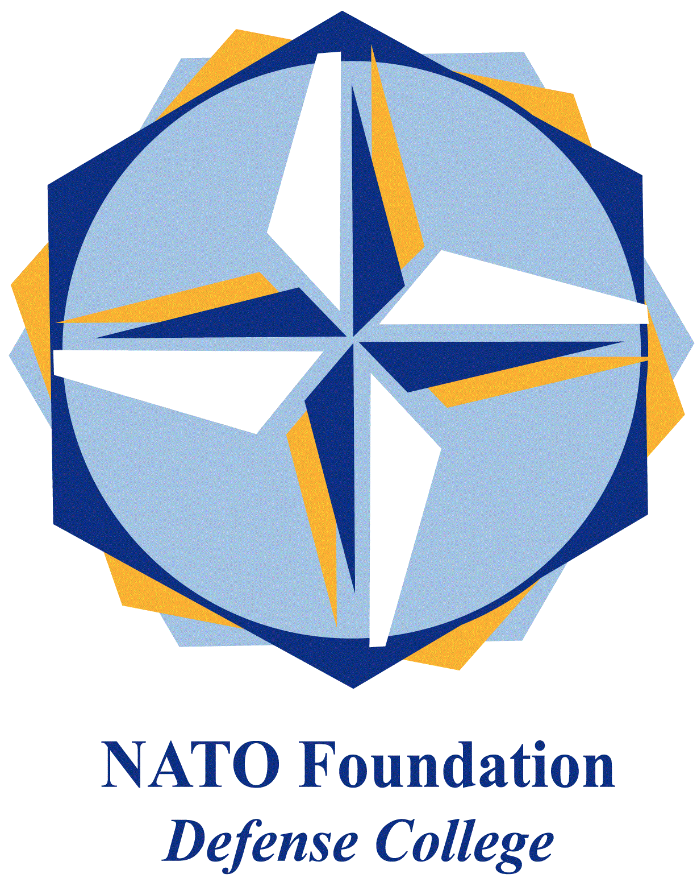
NATO DEFENSE COLLEGE FOUNDATION
STRATEGIC TRENDS
November 2015
RUSSIA
Ukraine keeps on shifting to the West
Ukrainian President Petro Poroshenko the 20th of November proudly announced that all EU parliaments have completed the process of ratifying the EU Association Agreement with Ukraine. The Association Agreement will lead to the establishment of a Ukrainian-EU free trade zone starting from the 1st of January 2016. Just one day before his announcement, Poroshenko asked the Ukrainian government to replace Russian-language texts with English ones on Ukrainian identification documents. What are the relevance of these two different developments and the connections between them?
The Ukrainian President tweeted also that, with the agreement’s ratification by the Brussels regional parliament and a Belgian language commission the same day, all 28 EU member states have now approved Ukraine’s pact with the European Union. He said in a second tweet that “[The] EU just informed us that all is ready to launch a free trade zone with Ukraine as of Jan. 1, 2016”.
The EU is already Ukraine’s biggest trading partner, with Kyiv conducting more than one-third of its trade with EU members. Ukraine signed the political portion of the Association Agreement with Brussels in March 2014, and the economic section three months later. In September 2014, the establishment of a Ukrainian-EU free-trade zone was postponed until 31/12/2015 after Russian complaints.
EU Trade Commissioner Cecilia Malmström said during a visit to Kyiv in mid-November that the EU-Ukraine Deep and Comprehensive Free Trade Area (DCFTA) agreement will “send a powerful signal that the regulatory environment in Ukraine is modern and efficient”. The EU will gradually lift tariffs and other trade barriers as Ukraine meets conditions set forth in the DCFTA.
When Poroshenko asked the government to carry out the Russian to English language switch he told that the request came after a petition from Ukrainian citizens demanding that the so called internal passports be changed. Most internal passports in Ukraine currently carry texts in Russian and Ukrainian.
A resident of the western city of Lviv, Svyatoslav Litynskiy, filed a lawsuit in early 2015 against a local passport agency, demanding an internal passport with text only in Ukrainian. He won the case in May and received such a passport in August.
Ukrainian-Russian relations have hit historic lows since Moscow annexed Ukraine’s Crimean Peninsula in 2014 and began supporting pro-Russian separatists in eastern Ukraine.

